
(All rights reserved)
SCHOOL OF PHYSICAL & MATHEMATICAL SCIENCES
DEPARTMENT OF STATISTICS & ACTUARIAL SCIENCES
FIRST SEMESTER, 2025/2026 ACADEMIC YEAR
END OF FIRST SEMESTER EXAMINATION
BLOCK II
ASTA607: COMPUTATIONAL STATISTICS I
NAME: MARTEY MICHAEL
STUDENT ID: 22424196
PROGRAM: MSc. STATISTICS

CODE
library(MASS)
data("crabs")
?crabs

OUTPUT
Description:
The crabs data frame has 200 rows and 8 columns, describing 5 morphological measurements on 50 crabs each of two colour forms and both sexes, of the species Leptograpsus variegatus collected at Fremantle, W. Australia.

CODE
data("crabs")
str(crabs)

RESULT
> str(crabs)
'data.frame': 200 obs. of 8 variables:
$ sp : Factor w/ 2 levels "B","O": 1 1 1 1 1 1 1 1 1 1 ...
$ sex : Factor w/ 2 levels "F","M": 2 2 2 2 2 2 2 2 2 2 ...
$ index: int 1 2 3 4 5 6 7 8 9 10 ...
$ FL : num 8.1 8.8 9.2 9.6 9.8 10.8 11.1 11.6 11.8 11.8 ...
$ RW : num 6.7 7.7 7.8 7.9 8 9 9.9 9.1 9.6 10.5 ...
$ CL : num 16.1 18.1 19 20.1 20.3 23 23.8 24.5 24.2 25.2 ...
$ CW : num 19 20.8 22.4 23.1 23 26.5 27.1 28.4 27.8 29.3 ...
$ BD : num 7 7.4 7.7 8.2 8.2 9.8 9.8 10.4 9.7 10.3 ...

COMMENTS:
The crabs data set is made up of 200 observations of 8 variables namely: sp, sex, index, FL, RW, CL, CW, and BD. sp and sex are factor (categorical variables) with two levels each whiles FL, RW, CL, CW, and BD are numerical (quantitative variables

CODE
sex_table <- table(crabs$sex)
sex_table
species_table <- table(crabs$sp)
species_table

OUTPUT
> sex_table <- table(crabs$sex)
> sex_table

F M
100 100
> species_table <- table(crabs$sp)
> species_table

B O
100 100

CODE
par(mfrow = c(1,2), mar = c(4,4,1,1))
barplot(species_table, main = "Bar Plot of Species", xlab = "Species", ylab = "Frequency", col = "red")
barplot(sex_table, main = "Bar Plot of Sex", xlab = "sex", ylab = "Frequency", col = "blue")

RESULT
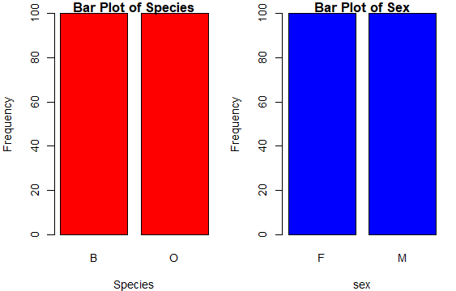
Figure 1 barpraph of species and sex
Figure 1 shows the bar graph of the group composition of Species and Sex, it can be observed that the frequency for each group is 100. That is they have equal bars and as such reduces biasing when comparing them.
- COMMENTS
From the frequency table ouput, it can be observed that across the four group, each has a frequency of 100. Also, the bargraph the group has equal bars. This implies that the data set is balanced across the groups.

CODE
boxplot(crabs$BD ~ crabs$sp, dataname = crabs, main = "Box Plot of Species", xlab = "Species", ylab = "Body Count", col = "red")

boxplot(crabs$BD ~ crabs$sex, dataname = crabs, main = "Box Plot of Sex", xlab = "Sex", ylab = "Body Count", col = "green")

RESULT
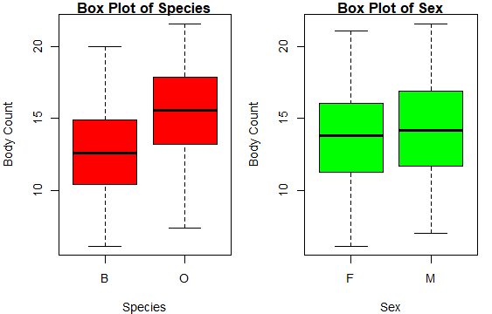
Figure 2 box plot of body count for species and sex

COMMENTS
Figure 2 shows a box plot of body count for species (red) and sex (green). It can be observed that for species, orange (O) species generally has higher body counts compared to blue (B) species. The minimum, first quartile, median, third quartile, and maximum body count of orange species is higher than that of blues species. Also from the body count box plot for sex, males (M) has slightly higher body counts than females (F)

- Fron the box plot, there are no outliers across the four groups (orange, blue, male and female species)
The median of orange species if higher than the median of blue species. The length of the box for both blue and orange species appear to be same, also the distance from the minimum value to the first quartile of blue species is shorter than the distance from the minimum value to the first quartile of orange species , and the distance from the third quartile to the maximum value of blue species is longer than the distance from the third quartile to the maximum value of orange species but the range appears to be the same. This means that the variability in body counts does not differ significantly for both orange and blue species.
Variability for sex also does not differ significantly both males and female species because the length of the box and the range appears to be the same.

- a.
CODE
hist(crabs$CL[crabs$sp == "B"], main = "Histogram of Species(B)", xlab = "Blue Species", ylab = "Carapace Length", col = "blue")

hist(crabs$CL[crabs$sp == "O"], main = "Histogram of Species(O)", xlab = "Orange Species", ylab = "Carapace Length", col = "Orange")

OUTPUT
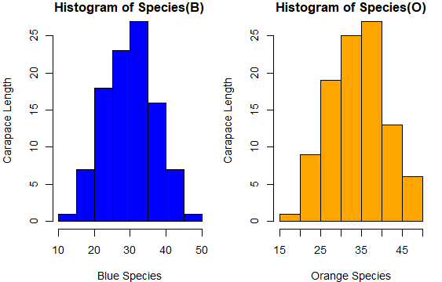
Figure 3 histogram of carapace length for each species

- The distribution of blue species is roughly normally distributed, mesokurtic and has one mode
The distribution of orange species is negatively skewed that is most of the values are to the right side of the mean. It is also mesokurtic and unimodal( has one mode)
The mode carapace length of both orange and blue is the same (25mm).

CODE
mean_FL_sp <- mean(crabs$FL[crabs$sp])
mean_FL_sp
mean_FL_sex <- mean(crabs$FL[crabs$sex])
mean_FL_sex

mean_RW_sp <- mean(crabs$RW[crabs$sp])
mean_RW_sp
mean_RW_sex <- mean(crabs$RW[crabs$sex])
mean_RW_sex

mean_CL_sp <- mean(crabs$CL[crabs$sp])
mean_CL_sp
mean_CL_sex <- mean(crabs$CL[crabs$sex])
mean_CL_sex

mean_CW_sp <- mean(crabs$CW[crabs$sp])
mean_CW_sp
mean_CW_sex <- mean(crabs$CW[crabs$sex])
mean_CW_sex

mean_BD_sp <- mean(crabs$BD[crabs$sp])
mean_BD_sp
mean_BD_sex <- mean(crabs$BD[crabs$sex])
mean_BD_sex

tab <- data.frame(mean = c("Species", "Sex"),
FL = c(mean_FL_sp,mean_FL_sex),
RW = c(mean_RW_sp,mean_RW_sex),
CL = c(mean_CL_sp,mean_CL_sex),
CW = c(mean_CW_sp,mean_CW_sex),
BD = c(mean_BD_sp,mean_BD_sex))
Tab

OUTPUT
> tab
mean FL RW CL CW BD
1 Species 8.45 7.2 17.1 19.9 7.2
2 Sex 8.45 7.2 17.1 19.9 7.2

CODE

OUTPUT

CODE

OUTPUT

CODE
pairs(crabs[, c("FL","RW","CL","CW","BD")])

OUTPUT
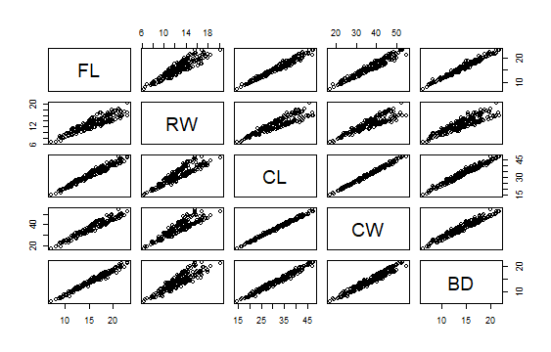
Figure 4 scatter plot of measurement

- From the plot, it can be observed that there is a strong positive relationship among the five measurement variables. This implies that for any increase in one, there will be in increase in the other variable.
FL (frontal lobe size (mm)) shows a strong positive relation with all the other variables
RW (carapace length (mm)) shows a strong positive relation with all the other variables
CL (carapace length (mm)) shows a strong positive relation with all the other variables
CW (carapace width (mm)) shows a strong positive relation with all the other variables
BD (body depth (mm)) shows a strong positive relation with all the other variable

- The data set crabs in the MASS package was analyzed using descriptive statistics. The dataset is a data frame has 200 observations, describing 5 morphological measurements on 50 crabs. It has 8 variables namely: sp (species), sex, index, FL (frontal lobe size (mm)), CL (carapace length (mm)), RW (carapace length (mm)), CW (carapace width (mm)), and BD (body depth (mm)). sp and sex are factor (categorical variables) with two levels each whiles FL, RW, CL, CW, and BD are numerical (quantitative variables)
Descriptive statistics for the categorical variables showed that they are of equal crabs.
The body count of both species and sex had no significantly different variability and no outlier was observed.
The distribution of species’ carapace length appeared to be roughly normal for blue and negatively skewed for orange species
The was a strong positive relationship among the numeral variables. This implies that a crab with a higher FL (frontal lobe size (mm)) is likely to have higher CL (carapace length (mm)), CL (carapace length (mm)), CW (carapace width (mm)), and BD (body depth (mm)).

